**Spring Core Maven**

**Exercise 1: Configuring a Basic Spring Application**

**Scenario:**

Your company is developing a web application for managing a library. You need to use the Spring Framework to handle the backend operations.

**Steps:**

1. **Set Up a Spring Project:**
   * Create a Maven project named **LibraryManagement**.
   * Add Spring Core dependencies in the **pom.xml** file.
2. **Configure the Application Context:**
   * Create an XML configuration file named **applicationContext.xml** in the **src/main/resources** directory.
   * Define beans for **BookService** and **BookRepository** in the XML file.
3. **Define Service and Repository Classes:**
   * Create a package **com.library.service** and add a class **BookService**.
   * Create a package **com.library.repository** and add a class **BookRepository**.
4. **Run the Application:**
   * Create a main class to load the Spring context and test the configuration.

**SOLUTION:**

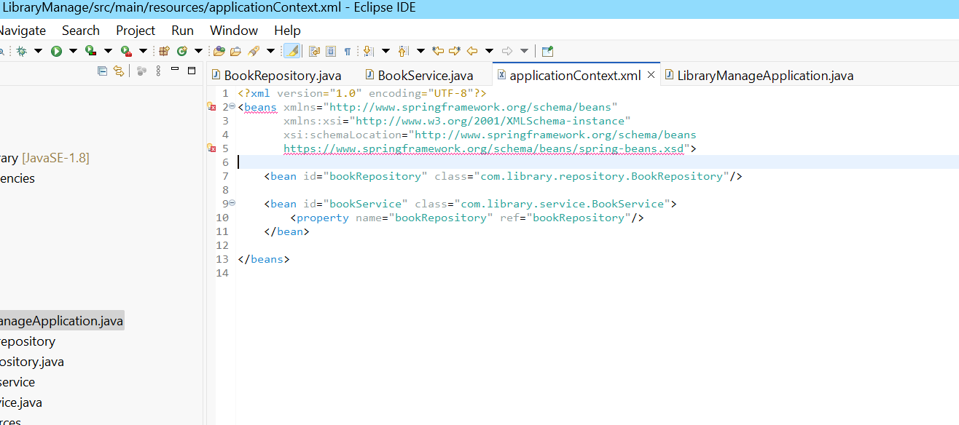

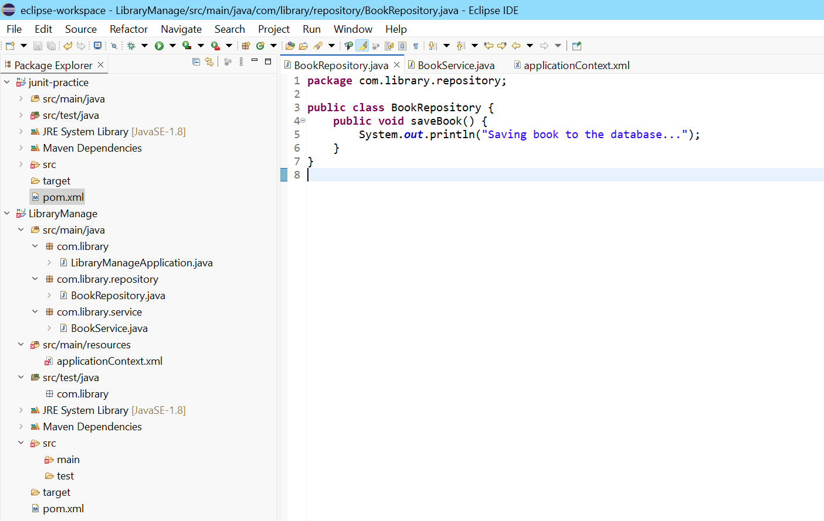

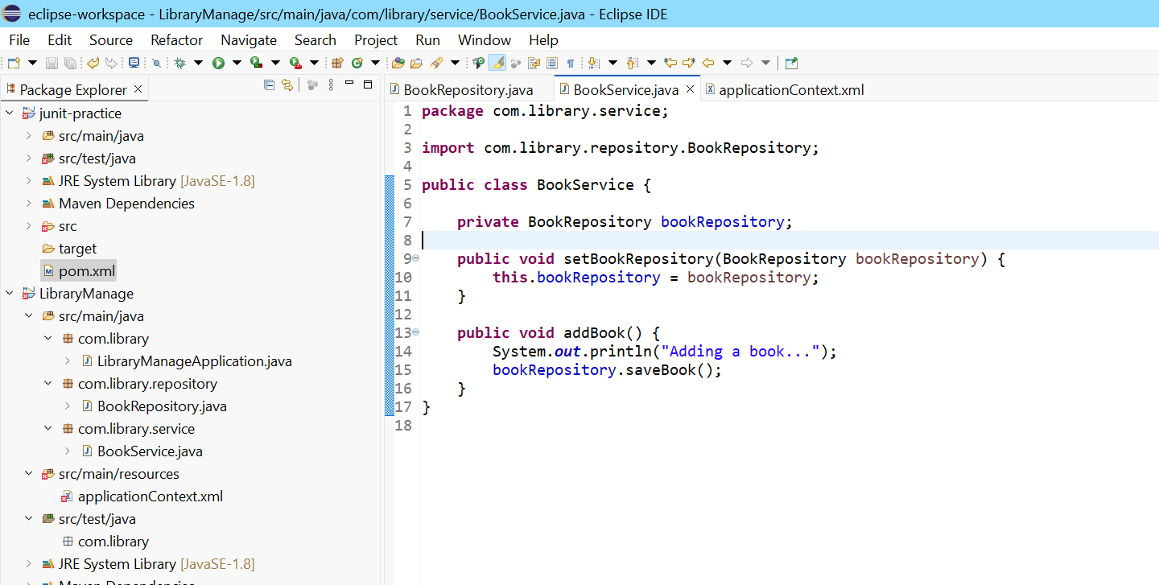

**Exercise 2: Implementing Dependency Injection**

**Scenario:**

In the library management application, you need to manage the dependencies between the BookService and BookRepository classes using Spring's IoC and DI.

**Steps:**

1. **Modify the XML Configuration:**
   * Update **applicationContext.xml** to wire **BookRepository** into **BookService**.
2. **Update the BookService Class:**
   * Ensure that **BookService** class has a setter method for **BookRepository**.
3. **Test the Configuration:**
   * Run the **LibraryManagementApplication** main class to verify the dependency injection.

**SOLUTION:**

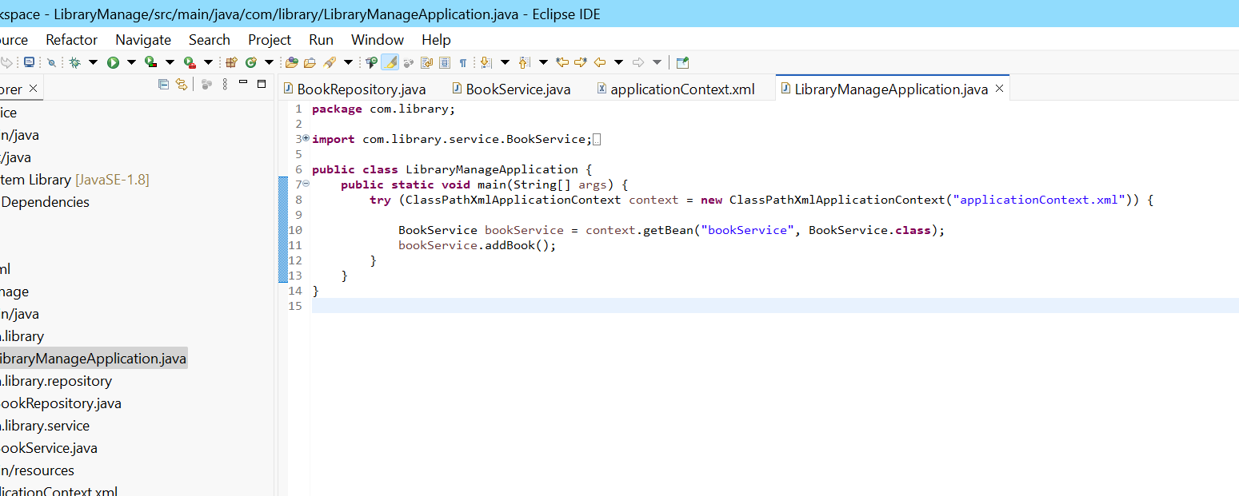

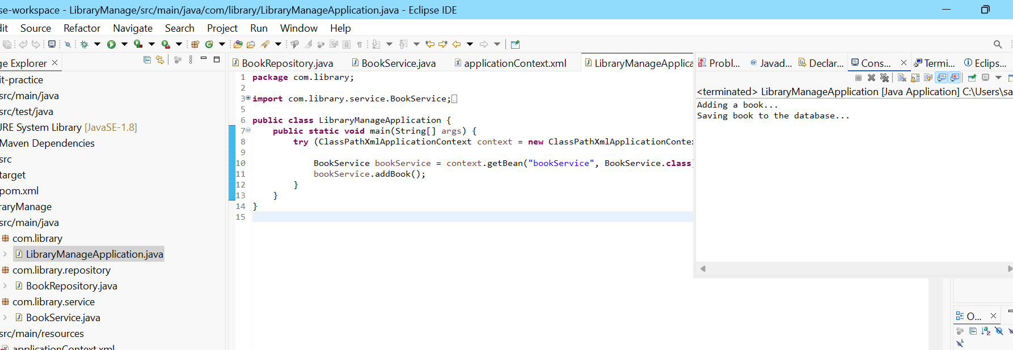

**Exercise 4: Creating and Configuring a Maven Project**

Scenario:

You need to set up a new Maven project for the library management application and add Spring dependencies.

Steps:

1. Create a New Maven Project:

o Create a new Maven project named LibraryManagement.

2. Add Spring Dependencies in pom.xml:

o Include dependencies for Spring Context, Spring AOP, and Spring WebMVC.

3. Configure Maven Plugins:

o Configure the Maven Compiler Plugin for Java version 1.8 in the pom.xml file.

**SOLUTION:**

